Nana Yaw Boampong Sapong

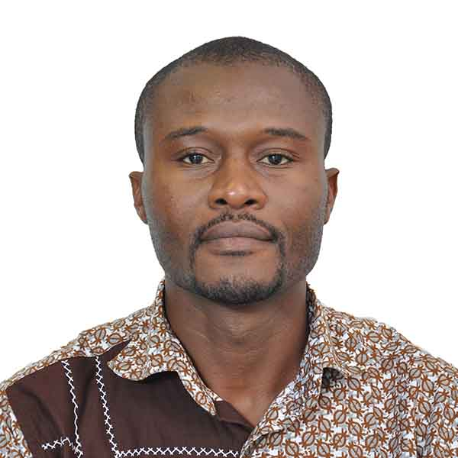

Nana Yaw Boampong Sapong
Lecturer
nysapong@ug.edu.gh

Education or Qualification:
Ph.D. (History), Southern Illinois University Carbondale, USA, 2004 - 2009
M.A. (History), Central Michigan University, USA, 2002 - 2004
B.A. (History and English), University of Ghana, 1997 - 2000

Research interests:
Sub-discipline(s): Social History, Intellectual History, Military History.

Themes: Social Movements and Democratization.
History of Higher Education in Africa.
Nationalism and the Politics of Decolonization.
History of the Ghana Armed Forces.
Pre-Colonial and Colonial Political Economy of Ghana.

Research abstract:

Nana Yaw Boampong Sapong is currently researching the problematic of the illusive global university. The 1990s and 2000s marked an important milestone in the transformation of African universities from colonial creations to global institutions. In Ghana, the University of Ghana’s fate was tied to the ascendency of neoliberal reforms, which changed the nature, function and outlook of the university. Neoliberal policies led to international partnerships that resulted in improvements in campus infrastructure, access to technology and internationalization. Paradoxically, the current changes also present problems associated with exploitation, marginalization and inequality. Current literature in critical university studies enjoin scholars of the study of Africa to revisit the original conception of higher education as a public good, and to be critical of the present levels of privatization of higher education, exploitation of academic labor, gender marginalization, and the rising cost of higher education. This project proposes an introspective study of the university’s current challenges associated with academic labor, gender inequality and neoliberal reforms.

Publications:

Books Edited
Sapong, N.Y.B. & J.O. Pohl. (eds.) (2014). Replenishing history: New directions to historical research in the 21st century in Ghana. Banbury, Oxfordshire: Ayebia Clarke. ISBN 9780992843601.

Book Chapters
Sapong, N.Y.B. & Harsanyi, D.P. (2018). Colonial dynamics of development in Ghana and Italy: A comparative historical perspective. In P. Quartey et al. (Eds.), Multidisciplinary perspectives on transformation in Africa (pp. 337-363). Accra: Sub-Saharan Publishers. ISBN 9789988550196.

Sapong, N.Y.B. (2016). Framing Contentious Politics in the Gold Coast: the Nkrumah Contingency, 1948 – 1951. in Bea Lundt and Christoph Marx (eds) Kwame Nkrumah Today, (Stuttgart: Verlag Franz Steiner) Ranke Gesellschaft.

Baku, D.E.K, Sapong, N.Y.B., and Amoah-Boampong, C. (2014). “Bridging the Ivory Tower: Professional history, Scholarship, and Public Engagement in Ghana” in Samuel Adjei-Mensah, Joseph Ayee, and Abena Oduro (eds.), Changing Perspectives on the Social Sciences in Ghana, (Dordrecht: Springer), 33-49. ISBN 9780992843601.

Sapong, N.Y.B. (2014). “Students at the Barricades: the 1960s and the Revival of Student Radicalism in Ghana” in Sapong, N.Y.B., and Otto, P. J., (eds.), Replenishing History: New Directions to Historical Research in the 21st Century in Ghana, (Banbury: Ayebia Clarke Publishing Ltd.), 26-46. ISBN 9780992843601.

Sapong, N.Y.B. & Amoako, P. (forthcoming). Women in universities in Africa. In O. Yacob-Haliso & T. Falola (Eds.) The Palgrave handbook of African women’s studies. Palgrave.

Baku, D.E.K., Sapong, N.Y.B., and Amoah-Boampong, C. (2014). “Charting a Course for the Historian’s Craft in Ghana” in Sapong, N.Y.B., and Otto, P. J., (eds.), Replenishing History: New Directions to Historical Research in the 21st Century in Ghana, (Banbury: Ayebia Clarke Publishing Ltd.), 1-5. ISBN 9780992843601.

Peer-reviewed Journal Articles
Sapong, N.Y.B. (2018). Capitalist exchange, consumerism and power in nineteenth century Gold Coast: Interrogating Ama Ata Aidoo’s Anowa and the contested personage of the merchant prince. Legon Journal of the Humanities, 29(2), 265-285.

Book Reviews

Sapong, N.Y.B. (2016). The politics of chieftaincy: Authority and property in colonial Ghana, 1920 – 1950. Africa Studies Quarterly, 16(3-4), 215.

Sapong, N.Y.B. (2009). Dreams of Africa in Alabama. H-Net: Humanities and Social Sciences Online. URL: http://www.h-net.org/reviews/showrev.php?id=24598.

Encyclopaedia Entries

Sapong, N.Y.B. (2016). Mali Empire. In J. M. MacKenzie (Ed.) The Encyclopedia of Empire. Wiley Blackwell. ISBN 9781118455074.

Sapong, N.Y.B. (2016). Asante Kingdom. In J. M. MacKenzie (Ed.) The Encyclopedia of Empire. Wiley Blackwell. ISBN 9781118455074.

Sapong, N.Y.B. (2012). Geraldo de Lima. In E. Akyeampong & H. L. Gates (Eds.) Dictionary of African biography. Oxford: Oxford University Press. ISBN – 13: 9780195382075.

Sapong, N.Y.B. (2012). Hilla Limann. In E. Akyeampong & H. L. Gates (Eds.) Dictionary of African biography. Oxford: Oxford University Press. ISBN – 13: 9780195382075.

Sapong, N.Y.B. (2012). Osei Tutu. In E. Akyeampong & H. L. Gates (Eds.) Dictionary of African biography. Oxford: Oxford University Press. ISBN – 13: 9780195382075.

Refereed Conference Papers
Amoah-Boampong, C. & Sapong, N.Y.B. (June 2018). Negotiating the African Diaspora in Ghana. California State University Office of International Programs Faculty Seminar. Theme: Ghana Calls. June 2018. University of Ghana Legon.

Sapong, N.Y.B. & Amoah-Boampong, C. (December 2017). Faithless Gods and Furious Poets: Encountering Historical Memory, Disillusionment, and Hope in Kofi Anyidoho’s Poetry. International Symposium and Spoken Art Festival: A Celebration of Kofi Anyidoho’s Contribution to African Literature and Culture. December 14-16, 2017. University of Ghana Legon.

Sapong, N.Y.B. (November 2015). Framing Social Movements and Democracy from Below. African Studies Association 58 Annual Conference. Theme: The State and Study of Africa: Civil Society and the Act of Resistance. November 17-21, 2015. San Diego, USA.

Sapong, N.Y.B. (November 2015). Modelling for Democracy in Africa. Public Lecture. November 17, 2015. George Bush School of Government and Public Service, Texas A&M University, USA.

Sapong, N.Y.B. & Harsanyi, D. P. (July 2015). Colonial Dynamics of Development in Ghana and Italy. 1ST International Conference on Multidisciplinary Research and Transformation in Africa. July 2, 2015. College of Humanities, University of Ghana Legon.

Sapong, N.Y.B. & Amoah-Boampong, C. (May 2015). Faculty Development and Productivity in Higher Education. International Conference on Education Research for Development in Africa (ICERDA). Theme: Harnessing Education Research for Evidence Based Development. May 4, 2015. University of Ghana Legon.

Professional Associations:
- Ghana Studies Association
- African Studies Association
- Historical Society of Ghana
- Institute for Humane Studies, George Mason University

