Dzifa Efodzi

Photo
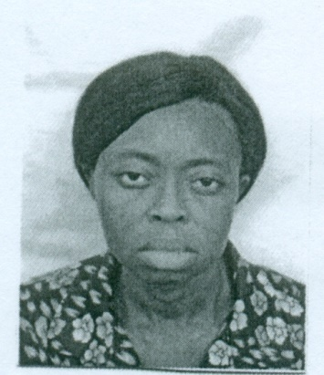

Dzifa Efodzi
Assistant Lecturer
defodzi@ug.edu.gh

Education or Qualification:
M. Phil. (Classics), University of Ghana, Legon, 2011 - 2014
B.A. (English and History), University of Cape Coast, 2001 – 2005

Research Interests:
Imperial Roman History
Ancient Greek and Roman History
Ancient Greek and Roman Social History
Gender in Ancient Greece and Rome
Leadership in ancient Greece and Rome
Greek and Roman Literature

Academic Awards/ Fellowships:
- A US$ 12,000 Andrew Mellon Foundation PhD Fellowship

Publications:
Books Authored
Use Chicago format

Books Edited
Use Chicago format

Book Chapters
Use Chicago format

Peer-review Journal Articles
Use Chicago format

Book Reviews
Use Chicago format

Encyclopedia Entering
Use Chicago format

Refereed Conference Papers
Use Chicago format

Grants:

Professional Associations:
- The Classical Association of Ghana

Affiliations to Research Institutions:

